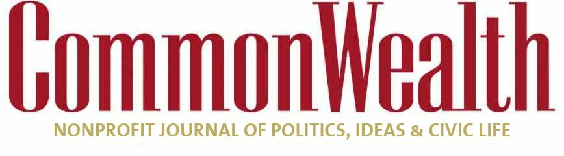

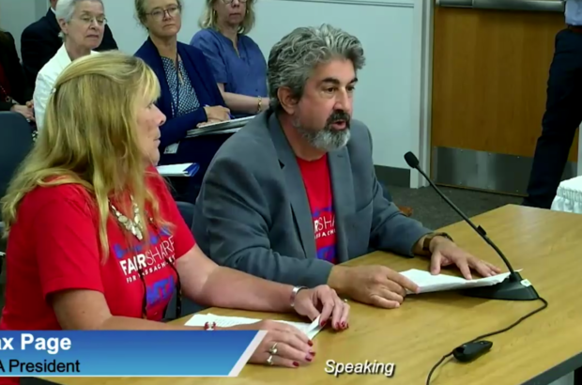

Max Page, president of the Massachusetts Teachers Association, testifying before the state Board of Elementary and Secondary Education at its August 2022 meeting along with MTA vice president Deb McCarthy.

[EDUCATION](https://commonwealthmagazine.org/category/education)**/**[OPINION](https://commonwealthmagazine.org/category/opinion)

**Teachers union wants ed reform money — but not accountability**

**MTA campaign against graduation test takes their stand to 'farcical extremes'**

****[CHARLES CHIEPPO](https://commonwealthmagazine.org/author/charles-d-chieppo/)**and **[JAMIE GASS](https://commonwealthmagazine.org/author/jamiegass/)**Apr 25, 2023**

**1**

**THE MASSACHUSETTS TEACHERS ASSOCIATION** is calling on its members to be “conscientious objectors” by refusing to administer MCAS and not let their own children take the dreaded tests. Such farcical extremes ensue when a special interest group has had too much power for too long.

Massachusetts’ landmark 1993 Education Reform Act transformed K-12 public education by providing substantial funding increases in return for accountability, high standards, and expanded school choice. SAT scores rose for 13 consecutive years. In 2005, the Bay State became the first state to lead all four categories tested on National Assessment of Educational Progress (NAEP). By 2007, Massachusetts eighth graders tied for first in the world in science testing.

But aside from more funding, the MTA was never a fan of the law. For well over a decade, they have been a buzzsaw financing politicians who support leveling reforms that were the foundation of the Bay State’s success. Now, the MTA has targeted the requirement that students pass basic MCAS tests in English, math, and science to graduate from high school—the heart of the historic law’s accountability provisions. It’s the last reform standing.

Since 2008, the MTA has led successful efforts to eliminate the law’s central provisions, including the independent agency that performed school district audits and ensured accountability for the billions of dollars taxpayers invest annually in public schools. Today, the MTA is pushing the legislators they fund so heavily to scrap test-based accountability.

But the reality is there’s barely any accountability left. For example, even after two scathing state audits of the Boston Public Schools, the Boston Teachers Union successfully lobbied Beacon Hill to punt on state receivership.

Mostly poor and minority students at the Commonwealth’s best-in-the-nation charter public schools perform far better than their peers on the tests the union calls “punitive,” and they also enjoy higher graduation and college matriculation rates. But the MTA and its allies stopped charter schools in their tracks. This time they had help from charter advocates who, by bringing a charter expansion to the statewide ballot, played to the union’s strengths of endless dues money and over 120,000 members to make calls and turn out for anti-charter rallies.

The MTA has couched much of its work to roll back reforms in the language of social justice. Recently, MTA vice president Deb McCarthy told *[CommonWealth](https://commonwealthmagazine.org/education/union-urges-teachers-and-students-to-opt-out-of-mcas/)* that MCAS hasn’t helped close race- and class-based achievement gaps, and claimed testing itself is racist.

It’s a curious statement. Between 1998 and 2005, before the dismantling of reform, Massachusetts was one of only three states to show significant increases in grade 8 reading scores; it was also [in the top three for narrowing achievement gaps.](https://pioneerinstitute.org/pioneer-research/transcripts/core-academic-knowledge/) In 2009, renowned standards expert E.D. Hirsch proclaimed, “If you are a disadvantaged parent with a school-age child, Massachusetts is the state to move to.”

Perhaps the MTA has learned that all-important political lesson: If you repeat something enough, no matter how outrageous and false, some people will believe it.

The results from over a decade of MTA policy dominance on Beacon Hill have been grim. Massachusetts’ performance on NAEP has fallen to a 19-year low. Many blame the pandemic, but data clearly show the problems began much earlier.

Between 2011 and 2019, before the pandemic, aggregated NAEP [math scores in grades 4 and 8 in Massachusetts fell by 5.8 points](https://pioneerinstitute.org/wp-content/uploads/NAEP-math-2011-19-2-1.pdf), more than in all but 17 states.  Reading was even worse. The [decline of 7.9 points](https://pioneerinstitute.org/wp-content/uploads/NAEP-reading-2011-19-2.pdf) was larger than in all but 14 states.

These results make you think Mary Tamer, director of the Massachusetts chapter of Democrats for Education Reform, may have been on to something when she told *CommonWealth* that MTA’s opposition to testing might have something to do with not liking the facts the tests are revealing.

The MTA and its allies have fought to build upon the funding increases that were part of the 1993 Education Reform Act, and they haven’t always been wrong. The Commonwealth already had among the best-funded schools in the country before a 2019 law wisely devoted an [additional $1.5 billion over seven years](https://www.bostonglobe.com/metro/2019/10/03/state-senate-passes-reform-bill/dvnWYRwFxQXsNaVXaxY33M/story.html) to reducing the spending gulf between poorer and more affluent school districts.

But when you combine generous and growing state and federal K-12 public education spending with performance declines that are among the nation’s steepest, perhaps it’s state taxpayers who might think about conscientiously objecting to public education policy dictated by the Massachusetts Teachers Association.

*Charles Chieppo is a senior fellow and Jamie Gass is the director of the Center for School Reform at Pioneer Institute, a Boston-based think tank.*

Meet the Author

[](https://commonwealthmagazine.org/author/charles-d-chieppo/)

[**Charles Chieppo**](https://commonwealthmagazine.org/author/charles-d-chieppo/)

Guest Contributor

[Bio »](https://commonwealthmagazine.org/author/charles-d-chieppo/) [Latest Stories »](https://commonwealthmagazine.org/author/charles-d-chieppo/#author-posts-by)

Meet the Author

[**Jamie Gass**](https://commonwealthmagazine.org/author/jamiegass/)

Guest Contributor, Pioneer Institute

[Bio »](https://commonwealthmagazine.org/author/jamiegass/) [Latest Stories »](https://commonwealthmagazine.org/author/jamiegass/#author-posts-by)